Exercise B: Draw softboxes and relationship lines for each relationship in both
directions.
a) Each EMPLOYEE must be assigned to one and only one DEPARTMENT.Each
DEPARTMENT must be responsible for one or more EMPLOYEEs.
b) Each EMPLOYEE must be assigned to exactly one DEPARTMENT. Each
DEPARTMENT may be responsible for exactly one EMPLOYEE.
c) Each TOWN may be the birthplace of one or more people. Each PERSON must
be born in one and only one TOWN.
d) Each PERSON may be visitor of one or more TOWNS. Each TOWN must visit
by many PEOPLE.
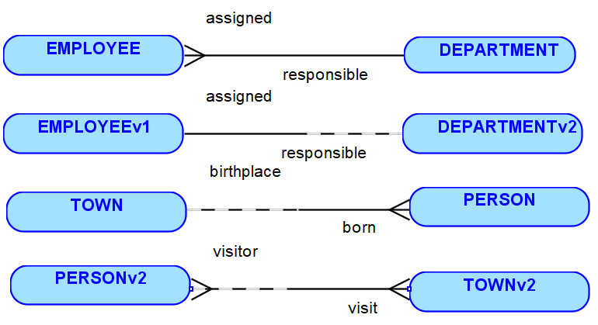

Exercise C: Determine how exclusive relationships should be modeled in the
following scenario.
Each COURSE instance in the Academic Database can either be held ONLINE or in a
SEATED location. Each SEATED location has a building name, room number and a
date/time when the COURSE is offered. The ONLINE classes have a logon id and a
password required to enter the COURSE.
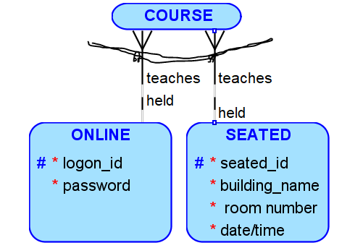
Exercise E: Resolve M: M relationships between FACULTY and the COURSE.
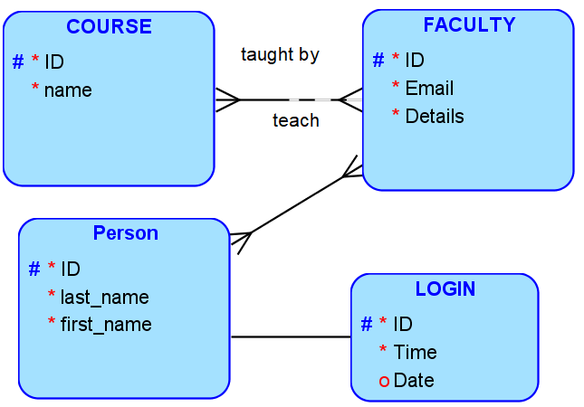
It’s wrong. M-M

